|  |
| --- |
|  |
|  |
|  |

Drainage Design Masterplan

How to improve the drainage system with an updated standard operating procedure, making insightful maps about current gaps and creating new designs with the Drainage Design Toolbox

|  |  |
| --- | --- |
| Contact us |  |
|  | |
| **Arnold van ‘t Veld**  Hydraulic Engineer  Site planning, Cox’s Bazar, Bangladesh  Email: arnold.vantveld@nelen-schuurmans.nl | |
|  | |
| **COVER PHOTOGRAPH:**  Collecting field verification points regarding flooding in camp 20 extension, Mai Gamaleldeen, 7 October 2019 | |
|  | |

Acknowledgements

I would like to thank all colleagues from UNHCR, IOM and WFP for their cooperation and collaboration by helping me improving the drainage system in the refugee camps of Bangladesh.

Contents

Goal 5

How 6

Who 7

Standard operating procedure 8

Field-based need assessment 9

Macro-scale need assessment 10

Drainage Masterplan Products 11

Need for drainage design map 12

Detailed drainage design 13

Drainage connectivity check 14

Landslide risk due to missing drainage check 15

Design Process 16

General guidelines 17

Improving existing streams or drainage system 19

Designing a new drainage system 21

Drainage Design Toolbox 23

1. Guess elevation for drainage network 24

2. Create elevation raster with drainage 25

3. Define major and minor streams 26

4. Sample hydraulic parameters 27

5. Calculate slope and discharge 28

6. Calculate width and velocity 29

7. Guess pour points on preferred scale 30

8. Create watersheds on preferred scale 31

9. Create drainage & landslide risk points 32

Annex A 33

Assessment criteria 33

Rainfall analysis 33

Design rainfall events 34

Our Work 36

|  |
| --- |
|  |
|  |

# Goal

Improve drainage to reduce floods, landslides and damage

Refugee camps in Kutupalong and Teknaf are vulnerable for floods, erosion and landslides. The camps are receiving high-intensity rainfall every year during the monsoon and cyclone seasons. Rainfall is causing floods. Fast-flowing streams are saturating or eroding soil. This is increasing landslides. Shelters, slopes, and structures are damaged.

This drainage masterplan focuses on improving tertiary to primary drainage system to reduces those risks. It focuses on all flow of water with a short response time of one hour. In this operation, these are all streams, except for the flow in the main rivers which are leaving the camp. The stream restoration plans are covering the improvements in those main streams.

|  |
| --- |
|  |
|  |

# How

### Improve connectivity

A connected and well-sloped drainage system will reduce uncontrolled flow. This will prevent erosion and reduce landslide risks.

### Improve dimensions

A properly sized drainage system will reduce floods and drain the area faster during extreme events.

### Set priorities

Locations with landslide risk and a lack of a proper drainage system are most vulnerable. Improving the upstream surroundings of those locations should be given highest priority.

|  |
| --- |
|  |
|  |

# Who

This reading guide explains more about the expected users of the different chapters.

### Standard operating procedure

|  |  |
| --- | --- |
| **All units and partners** | The procedure clarifies how drainage improvements are executed and which parties are involved. |

### Drainage Masterplan Products and Design Process

|  |  |
| --- | --- |
| **All units and partners** | Understanding general design guidelines Overview of existing maps to improve the drainage system |
| **Designer / GIS expert** | Which maps could be made and how do they look like Guidelines and procedures to design a new drainage system |

### Drainage Design Toolbox

|  |  |
| --- | --- |
| **Designer / GIS expert** | Understanding the principles with a one-pager of each tool with goal, data requirement, results and assumptions. This could be used as a reference document. |

|  |
| --- |
|  |
|  |

# Standard operating procedure

Providing a general working process for improving drainage

The current working process regarding the design of drainage could be improved. This chapter describes two standard operating procedures with its working process. The first working process is based on requests to improve drainage from the field. This method adds one short assessment by site planning to the current working process. This assessment specifies if a detailed design is needed in that area. The second working process is using maps on macro scale to improve the drainage system.

|  |  |
| --- | --- |
| Field-based need assessment |  |

*Reducing floods and landslide risk by doing a check on connectivity and dimensioning and improve the drainage design where necessary.*

### Field survey

|  |  |
| --- | --- |
|  | An assessment is made regarding the drainage system during a field survey or through a damage report. This could be a gutter which is damaged, a drainage channel which is missing or a potential landslide risk due to erosion. |

### Site improvement request or draft design

|  |  |
| --- | --- |
|  | The project area is selected by shelter partner, shelter or another unit.  A draft design for a small area could be made by any technical unit. This design should consist of a (new) alignment and drainage dimensioning.  A site improvement request could be made which could be done by any unit. This request comes with a location, picture and explanation of the project or through a joint field visit. For larger areas, an integrated project with a site plan is advised. |

### Design (check)

|  |  |
| --- | --- |
|  | If a draft design is provided, Site Planning unit performs a check on the proposed alignment and dimensioning of the drainage system. Only for the larger streams, a detailed design by site planning is necessary for this step. If a site improvement request is made, Site Planning will provide a drainage design with alignment and dimensions. |

### Bill of quantities

|  |  |  |
| --- | --- | --- |
|  | Shelter Partner in collaboration with the Shelter unit makes a bill of quantities based on the design. In this process, shelter takes into account the required effort by excavation or landfill to make the surroundings flowing towards the drainage system. |  |

### Implementation

|  |  |
| --- | --- |
|  | Shelter Partner in collaboration with the Shelter unit performs supervision during the implementation phases. Shelter checks direction/slope, proper dimensions and curved bottom profile, to improve low discharges, of the drainage system. |

|  |  |
| --- | --- |
| Macro-scale need assessment |  |

*Reducing floods and landslide risk by improving connectivity of the drainage system by performing surveying and GIS analysis on macro scale.*

### Mapping

|  |  |
| --- | --- |
|  | Information management unit surveys the current drainage system. Only the current alignment is required for a GIS analysis on macro-scale. Other information, like dimensions and material, are recommended to survey for designing purposes. This database is updated after implementation. |

### GIS analysis

|  |  |
| --- | --- |
|  | Site planning unit is performing a GIS analysis on the connectivity of the drainage system. This connectivity check could be used to identify vulnerable locations to landslide risk due to missing drainage. |

### Ground truthing

|  |  |
| --- | --- |
|  | Site planning unit initiates a field visit with other relevant units. The identified vulnerable locations or locations with missing drainage should be checked. This ground-truthing will tell: 1) if the drainage system is really missing and 2) if the risk for landslides is identified correctly. |

### Design

|  |  |
| --- | --- |
|  | Site planning unit makes a detailed drainage design in collaboration with Shelter (Partner), Site Management (Support), Environment and/or WASH unit. This design process could be integrated with other projects in this area regarding site planning, like building shelters or improving the environment. |

### Bill of quantities

|  |  |
| --- | --- |
|  | Shelter unit makes a bill of quantities based on the design. In this process, shelter takes into account the required effort by excavation or landfill to make the surroundings flowing towards the drainage system. |

### Implementation

|  |  |
| --- | --- |
|  | Shelter unit performs supervision during the implementation phases. Shelter checks direction/slope, proper dimensions and the required curved bottom for dry weather flow of the drainage system. |

|  |
| --- |
|  |
|  |

# Drainage Masterplan Products

Improving the connectivity and sizing of the drainage system

Translating information into clear maps that are useful for a larger group of people is an important step in transferring your knowledge about the drainage system to those in the field. This chapter describes four options to translate the results from the drainage design toolbox into four maps that could be used in the field or other next steps, like making a bill of quantities.

|  |  |  |
| --- | --- | --- |
| Need for drainage design map | Afbeeldingsresultaat voor arcgis toolbox | |
|  | | |
|  | |

### Goal

Giving guidance for which area’s drainage dimensioning is really needed and which areas don’t need drainage dimensioning.

### Toolbox Process

|  |  |  |  |  |  |
| --- | --- | --- | --- | --- | --- |
| Tool 1 | Tool 2 | Tool 3 | Tool 4 | Tool 5 | Tool 6 |
|  |  |  |  |  |  |
| Optional | Optional |  |  |  |  |

### Styling and categorizing

* No design: a width smaller than 0.25 m is smaller than a regular drain (0.3 x 0.3 m) and doesn’t need drainage dimensioning.
* Simple design: for widths’ smaller than 0.5 m a double-sized drain (0.6 x 0.3 m) should fit.
* Detailed design: for widths smaller than 1 m, a drainage design study is necessary.
* Critical design: for widths larger than 1 m, a drainage design study is necessary and options for diversion could be investigated.

Other categories with other parameters, like discharge, slope or velocity could be introduced as well.

|  |  |  |
| --- | --- | --- |
| Detailed drainage design | Afbeeldingsresultaat voor arcgis toolbox | |
|  | | |
|  | |

### Goal

Creating a map with a detailed drainage design which is ready for implementation. The next chapter will explain more about how this design process could be done.

### Toolbox Process

|  |  |  |  |  |  |
| --- | --- | --- | --- | --- | --- |
| Tool 1 | Tool 2 | Tool 3 | Tool 4 | Tool 5 | Tool 6 |
|  |  |  |  |  |  |
| Optional | Optional |  |  |  |  |

### Styling and categorizing

A map with dimensions and length of the drainage system. If necessary, information about the required excavation depth could be added as well. Based on this map a bill of quantities could be made by the shelter unit.

|  |  |  |
| --- | --- | --- |
| Drainage connectivity check | Afbeeldingsresultaat voor arcgis toolbox | |
|  | | |
|  | |

### Goal

Checking the performance of the current drainage network by showing all streams in the area without surveyed drainage network.

### Toolbox Process

|  |  |  |
| --- | --- | --- |
| Tool 1 | Tool 2 | Tool 3 |
|  |  |  |

### Styling and categorizing

Existing drainage (green) should be placed on top of the “streams for connectivity” layer (red). By making the existing drainage system a little bit thicker all streams which are close to the current drainage system will fall out of sight. Only not connected streams will show up on the map.

The stream order in the column “grid code” could be used to vary with the level of detail that you would like to have in your map. For most cases, it is advisable to at least filter a grid code of 1 out of your map. This will highlight more important streams to give more priority to them.

|  |  |  |
| --- | --- | --- |
| Landslide risk due to missing drainage check | Afbeeldingsresultaat voor arcgis toolbox | |
|  | | |
|  | |

### Goal

Providing a priority map for location with a missing drainage system and a landslide risk

### Toolbox Process

|  |  |  |  |
| --- | --- | --- | --- |
| Tool 1 | Tool 2 | Tool 3 | Tool 9 |
|  |  |  |  |

### Styling and categorizing

The same layout could be used as in the ‘drainage connectivity check’ above. Two new layers are added: landslide susceptibility and drainage – landslide risk points.

The landslide susceptibility could be added below the other layers. By showing only the values with a risk and making the others a little bit transparent, the map is still visible below it.

The points of the landslide – drainage risk could be added on top of all layers and could be styled in any desired way which shows urgency.

|  |
| --- |
|  |
|  |

# Design Process

This chapter helps the designer of the drainage system in their design process. In the first chapter, some general design principles are described for the Bangladesh refugee camps. Many of those principles will be the same in other countries. Please read them carefully.

Then two design process are described: Improvement existing streams or drainage system or designing a new drainage system. As long as the alignment of the current natural streams or drainage system stays approximately the same, the first method is suitable for your design process. If the alignment or elevation changes drastically, the second method should be used.

|  |  |
| --- | --- |
| General guidelines |  |

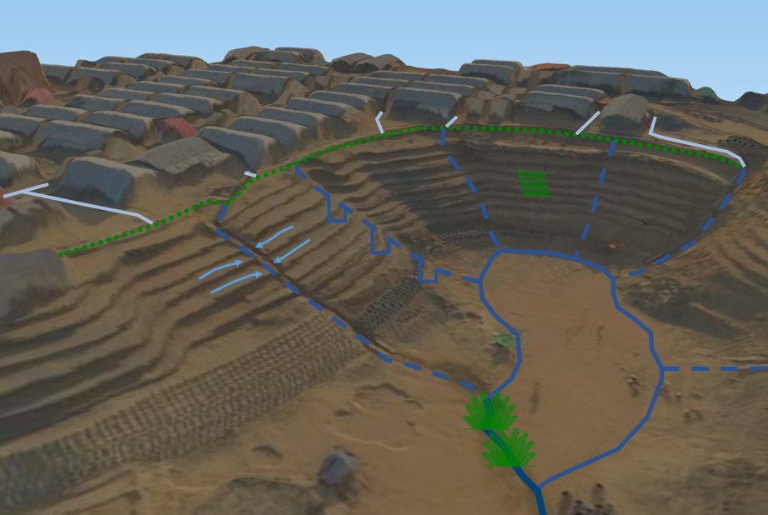

Drainage in the camp consists of three levels:

* Primary drainage: “drains the water out of the secondary valleys; connects to primary valley drainage or river.”
* Secondary drainage: “drains water down the hill; connects the household drainage or tertiary drainage to the valley drainage”
* Tertiary drainage: “collects the drainage of various households or streets and brings it to the secondary drainage system.”

### General guidelines up to household drainage

|  |  |
| --- | --- |
|  | **Connectivity**  All drainage systems need to be connected from household drainage up to primary drainage. If possible multiple connections to bring water down the slopes is preferred to avoid any problems with clogging |
|  | **Sizing check** Sizing matters when multiple streams come together. The drainage needed map shows if sizing is necessary for your location. |
|  | **Avoid long flat areas**  Flat areas are hard to drain. It improves a smoother flow of water to flatten the steep slopes and increase the slope in the flat areas. |
|  | **Curved profile** A drainage system with a curved profile allows flow more easily with low flows like during dry weather. |

### Slope drainage

|  |  |
| --- | --- |
|  | **Ridgeline drainage**  A ridgeline drain collects all the water from the hill. It prevents this water from flow down in an uncontrolled way. This prevents erosion and landslides. |
|  | **Apply rooted vegetation along slopes** Apply deeply rooted vegetation increases the stability of the slopes and diminish erosion. Furthermore, it increases the livelihood in the camps. |
|  | **Slow down water in chutes** Slopes could be very steep which increase the velocity of the water and its destructive force. Slowing down this water by using manholes, zig-zag or other measures could prevent damage or erosion. |
|  | **Terrace flow towards chutes** Along slopes, all water should be diverted towards the chutes to avoid any waterlogging or uncontrolled flow. Waterlogging and uncontrolled flow could induce landslides or heavy erosion. |
|  | **Catching drains** At the bottom of the hill, all the water coming from the chutes needs to be captured by a catching drain. This drain will prevent heavy soil erosion in the valleys and also makes it possible to prepare land for different types of land use. |

### Major streams

|  |  |
| --- | --- |
|  | **Keep streams green** Keep streams as natural and green as possible to improve infiltration and reduce flow speed. Creating environmentally friendly streams will increase the livelihood of the camps and provides options to treat the contaminated water by using vegetation with filtering capacities. Please involve the Environment unit for more information. |
|  | **Design culverts carefully** Design culverts based on expected discharge to either store water temporarily as a reservoir in the upstream areas or drain as fast as possible for flood-prone areas |
|  | **Toolbox not designed for rivers** The toolbox is designed for catchments with a response time or time of concentration of less than one hour. Rivers, like the Madhurchara river, have a larger response time. All its tributaries are small enough for the tool. |

|  |  |
| --- | --- |
| Improving existing streams or drainage system | Afbeeldingsresultaat voor arcgis toolbox |

### Run drainage toolbox from at least tool 3 to tool 6 in ArcGIS

|  |  |  |  |  |  |  |  |
| --- | --- | --- | --- | --- | --- | --- | --- |
| Tool 1 | Tool 2 | Tool 3 | Tool 4 | Tool 5 | Tool 6 | Tool 7 | Tool 8 |
|  |  |  |  |  |  |  |  |
| Optional | Optional |  |  |  |  | Optional | Optional |

**Tip**: Back-up the file ‘drainage design’ from tool 6.

### Change the alignment as desired

The toolbox proposes an alignment of the drainage system. However, in most cases, you would like to change the alignment due to various reasons. As long as the runoff area doesn’t change drastically, it is possible to change the alignment a bit. Please remember, that the drainage system should still be in the lowest place compared to the surroundings. Other options in this step are:

* Simplify lines
* Merge short lines or lines with similar slope
* Split lines at drastic change in slope, like a waterfall or steep slope

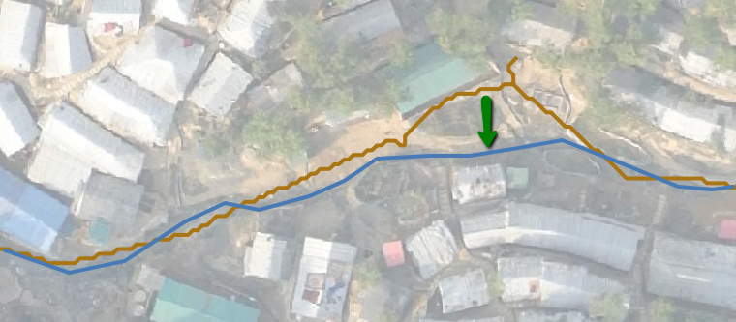

In case the alignment is drastically changed, streams are diverted or merged, please follow the next design process guide.

### Check the minimum and maximum elevation

In most cases, the calculation of the minimum and maximum elevation along the streams could be improved. Either because in tool 2 added drainage system is not in the original DEM or the DEM contains some irregularities along the main stream due to vegetation or buildings.

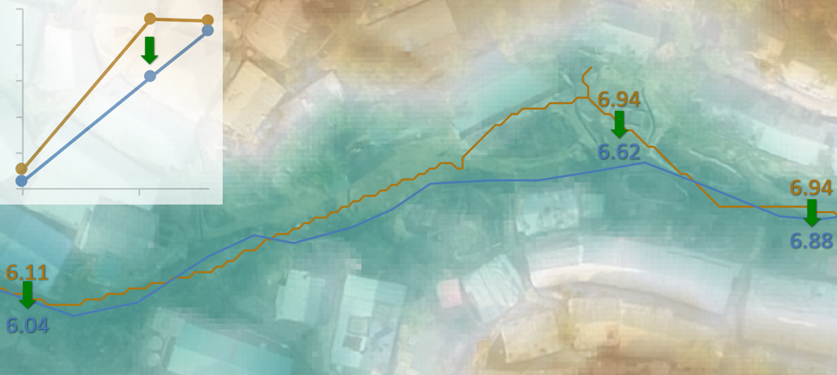

Giving guidance for which area’s drainage dimensioning is really needed and which areas don’t need drainage dimensioning.

### Recalculate slope, width and velocity with tool 5 and 6 in ArcGIS or QGIS

### Is this a desired and implementable width?

|  |  |
| --- | --- |
| ✓ | Great, please go to step 6 |
| ✗ | Change one or more of the following parameters:   * **Depth:** This is the easiest way to increase the discharge capacity and reduce the width of the drainage channel to implement in the field. Rerun Tool 6. * **Slope:** In some places, it is possible to increase the slope on flat parts and decrease the slope on steep parts of the stream. Change the minimum and maximum elevation accordingly and rerun tool 5 and 6.  This option requires excavation or landfilling during implementation. * **Alignment:** Change the alignment to reach a lower part of the area and change the minimum and maximum elevation accordingly. Rerun tool 5 and 6 |

### Assume (higher) implementable values for width and depth and create a map

|  |  |
| --- | --- |
| Designing a new drainage system | Afbeeldingsresultaat voor arcgis toolbox |

### Use AutoCAD and/or QGIS to create a new shapefile

This shapefile should have a projection in meters, like WGS – UTM 46, and the following attributes:

* Geometry consisting of lines
* ‘min_elev’: elevation of most downstream part of the line (e.g. 15.5 m)
* ‘max_elev’: elevation of the most upstream part of the line (e.g. 16.5 m)
* ‘runoff’: contributing area towards that drainage line (e.g 300.25 m2)
* ‘depth’: Initial assumption for the depth (e.g. 0.3 m)

### Get the minimum and maximum elevation

There are three options:

* Add elevation during your design process in AutoCAD and export it to QGIS
* Update elevation data in QGIS manually or by using QGIS tools.
* Use your proposed drainage lines as input for toolbox in ArcGIS.  
  Is the elevation regarding the lowest point of the drainage system changed?  
  If yes, start at tool 1.  
  If no, start at tool 2 and add a column ‘min_elev’ with a value below current DEM, e.g. 0 to make sure that the water will follow the DEM.

|  |  |  |  |
| --- | --- | --- | --- |
| Tool 1 | Tool 2 | Tool 3 | Tool 4 |
|  |  |  |  |
| Optional |  |  |  |

This method will give an estimate of the runoff area as well.

### Get the contributing runoff area

There are three options again:

* Adding proposed drainage lines in toolbox as described above in step 2.
* Calculate the expected run-off area in AutoCAD based on designed contour lines and expected flow.
* Use natural streams and watersheds to calculate the run-off area  
  Natural streams and watersheds could be generated once for the whole camp.  
  This method could be executed as described below.

1. Use stream and watershed analysis from the toolbox with only a DEM as input.

|  |  |  |
| --- | --- | --- |
| Tool 3 | Tool 7 | Tool 8 |
|  |  |  |

1. Change the sub-watersheds based on the new proposed drainage lines.  
   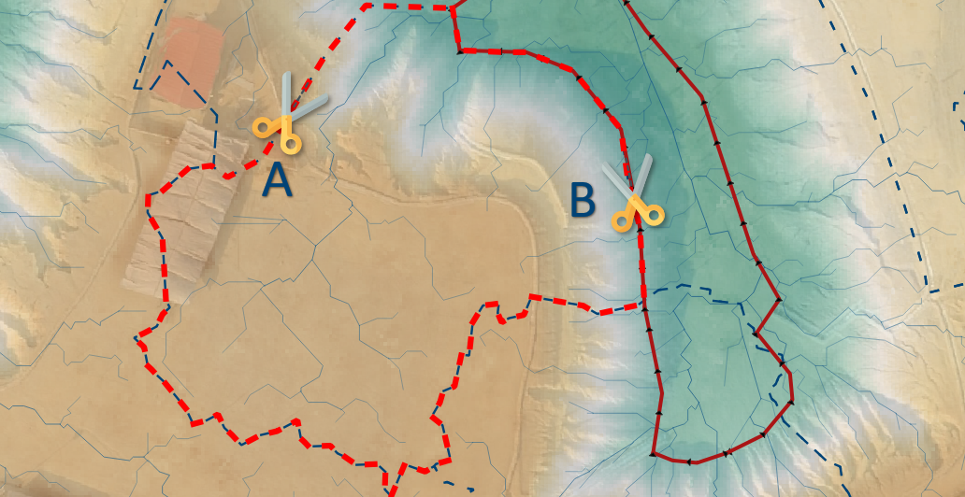

A. Cut the sub-watersheds between the streams to the endpoint of the drainage line

B. Cut the sub-watersheds along the streamlines if they are along a slope

1. Calculated the contributing runoff area and add them to lines.  
   For most upstream lines:

$$Runoff area [m^{2}]= Contributing area \left[m^{2}\right]$$

For other lines:

$$Runoff area \left[m^{2}\right]= Contributing area \left[m^{2}\right]+ Contribution upstream drainage [m^{2}]$$

### Calculate slope, width and velocity in ArcGIS or QGIS

### Is this a desired and implementable width?

|  |  |
| --- | --- |
| ✓ | Great, please go to step 6 |
| ✗ | Change one or more of the following parameters:   * **Depth:** This is the easiest way to increase the discharge capacity and reduce the width of the drainage channel to implement in the field. Rerun tool 6. * **Slope:** Increase the slope of the drainage system in flat areas. This option requires excavation or landfilling during implementation. Change the minimum and maximum elevation accordingly and rerun tool 5 and 6. * **Alignment:** Change the alignment to reach a lower part of the area and/or divert the water via another drainage line. Change the runoff area, minimum and maximum elevation accordingly and rerun tool 5 and 6. |

### Assume (higher) implementable values for width and depth and create a map

|  |
| --- |
|  |
|  |

# Drainage Design Toolbox

Generating useful maps and designs with limited data

This chapter explains the purpose of the toolbox. Every page describes one of the tools inside this toolbox with its main purpose, data requirement, result and assumptions. It helps in selecting the tools required for your working process. A tutorial for ArcGIS and QGIS is provided in the document ‘Instruction Manual – Drainage Design Toolbox’.

|  |  |  |  |
| --- | --- | --- | --- |
| 1. Guess elevation for drainage network | | Afbeeldingsresultaat voor arcgis toolbox | |
| **Before:** | **After:** | | |
|  |  | | |
|  | | |

### Goal

Get a representative minimum elevation value for the existing or designed alignment of the drainage system. This minimum elevation value is used to insert the drainage network into the elevation raster (tool 2). This helps the hydrology toolbox (tool 3) to follow the drainage network in the stream analysis.

### Data requirement

|  |  |
| --- | --- |
|  | **Elevation (raster)**  Digital elevation model (DEM) with a projection in meters, like WGS – UTM 46, and a high resolution, preferably 0.5 m, of the whole project catchment. |
|  | **Drainage network (lines)**  Location of existing or proposed drainage network in lines in the same projection and extent as the DEM. Attribute information is not needed for this exercise. The preferred line length for continuing drains is between 10 and 20 m. **Tip**: use ArcGIS ‘Generate Points at Lines’ + ‘Split line at point’ for best automatic result, otherwise use ‘split lines by maximum length’ in QGIS. |

### Result

|  |  |
| --- | --- |
|  | **Drainage network with elevation information (lines)**  Minimum and maximum elevation is sampled along the lines. |

### Assumptions

* Drainage depth could be estimated with sampled lowest elevation.
* Lowest elevation could be estimated with a sample distance of 5m.

|  |  |  |
| --- | --- | --- |
| 2. Create elevation raster with drainageAfbeeldingsresultaat voor arcgis toolbox | | |
| **Before:** | **After:** | |
|  |  | |
|  | |

### Goal

The drainage system is normally not fully included in the elevation raster. This tool inserts the elevation of the drainage network in the elevation model. This helps the hydrology toolbox (tool 3) to follow the drainage network in the stream analysis.

### Data requirement

|  |  |
| --- | --- |
|  | **Elevation (raster)**  Digital elevation model (DEM) with a projection in meters, like WGS – UTM 46, and a high resolution, preferably 0.5 m, of the whole project catchment. |
|  | **Drainage network with elevation information (lines)**  Location of drainage network in lines in the same projection as the DEM. Attribute column ‘min_elev’ is available with drainage elevation in MSL. |

### Result

|  |  |
| --- | --- |
|  | **Elevation with drainage network (raster)**  Digital elevation model (DEM) with a drainage network added to the model based on the lowest value along the drainage line. |

### Assumptions

* The lines of the drainage network are not linking two sides of a hill together. Lines shorter than 20 m will mostly prevent this from happening.
* A stream will stay inside the drainage unless one of the neighbouring cells is lower than the lowest elevation value along the drainage line.
* The required drainage width is the same as cell size. A stream analysis requires only one pixel as stream width for a good analysis in the Hydrology toolbox.

|  |  |  |  |
| --- | --- | --- | --- |
| 3. Define major and minor streams | | Afbeeldingsresultaat voor arcgis toolbox | |
| **Before:** | **After:** | | |
|  |  | | |
|  | | |

### Goal

Firstly, estimate the location of the main and small streams inside the study area.   
Secondly, if available, estimate where the streams follow the drainage system.

### Data requirement

|  |  |
| --- | --- |
|  | **Elevation with or without drainage (raster)**  Digital elevation model (DEM) with a projection in meters, like WGS – UTM 46, and a high resolution, preferably 0.5 m, of the whole project catchment. Including the drainage system with tool 1 and 2 is optional. |

### Result

|  |  |
| --- | --- |
|  | **Stream network for design purposes (lines)**  Main streams inside your selected catchment area. An attribute column “grid code” is available, which provides the stream order. |
|  | **Stream network for connectivity purposes (lines)** All streams inside your selected catchment area. An attribute column “grid code” is available, which provides the stream order. |
|  | **Various additional products for the next tools (raster)** The toolbox generates the following rasters as additional products: Fill, Flow Accumulation (flowacc), Flow direction (flowdir), Run-off area (runoff) |

### Assumptions

* Hydrology toolbox of ArcGIS could be used to estimate small and main streams. Therefore, the quality of the DEM determines the quality of the end result.
* The whole catchment is included in the analysis.

|  |  |  |  |
| --- | --- | --- | --- |
| 4. Sample hydraulic parameters | | Afbeeldingsresultaat voor arcgis toolbox | |
| **Before:** | **After:** | | |
|  |  | | |
|  | | |

### Goal

Estimate elevation and runoff area for slope and discharge calculation in tool 5.

### Data requirement

|  |  |
| --- | --- |
|  | **Original elevation (raster)**  Digital elevation model (DEM) with a projection in meters, like WGS – UTM 46, and a high resolution, preferably 0.5 m, of the whole project catchment. This DEM does not contain the drainage network added in tool 2. |
|  | **Run-off (raster)** Raster that provides the runoff area towards that point as a raster. |
|  | **Stream network for design purposes (lines)**  Location of the main streams inside your selected catchment area. |

### Result

|  |  |
| --- | --- |
|  | **Drainage design with added elevation and run-off (lines)** Location of the drainage system with maximum and minimum elevation along the drainage line and amount of run-off towards that drainage line. |

### Assumptions

* Maximum elevation is at the upstream part of the line.
* Minimum elevation is at the downstream part of the line.
* 75% percentile of the run-off area is used as representative for the whole line.
* Stream network lines overlay with the run-off raster (no simplification is used).
* Initial guess for the drainage depth without freeboard is 0.3 m for tool 6.

|  |  |  |  |
| --- | --- | --- | --- |
| 5. Calculate slope and discharge | | Afbeeldingsresultaat voor arcgis toolbox | |
| **Before:** | **After:** | | |
|  |  | | |
|  | | |

### Goal

Preparing ‘width and velocity’ calculation of tool 6 by calculation slope and discharge.

### Data requirement

|  |  |
| --- | --- |
|  | **Drainage design with added elevation and run-off (lines)** Location of the drainage system with maximum and minimum elevation along the drainage line and amount of run-off towards that drainage line. **Tip**: Elevation and runoff values could be changed manually in the design process. |
|  | **Design rainfall event** Select a rainfall intensity for a one-hour rainfall event. Please make sure that the response time of the catchment is less than one hour. Otherwise, you are overestimating. Default is 50 mm in one hour, see Annex A for more information. |

### Result

|  |  |
| --- | --- |
|  | **Drainage design with slope and discharge (lines)** Location of the drainage system with slope, discharge, minimum and maximum elevation, run-off area and assumed depth without freeboard. |

### Assumptions

* Minimum and maximum elevation should be changed by the designer or GIS specialist if this tool is used for the final design stage. In many situations, tool 4 only roughly indicates the minimum and maximum elevation value due to quality issues of the DEM.

|  |  |  |  |
| --- | --- | --- | --- |
| 6. Calculate width and velocity | | Afbeeldingsresultaat voor arcgis toolbox | |
| **Before:** | **After:** | | |
|  |  | | |
|  | | |

### Goal

Provides a preliminary design of the drainage system, by calculating the width based on an assumed depth without freeboard. In this tool, the velocity will be calculated to check for expected high velocities.

### Data requirement

|  |  |
| --- | --- |
|  | **Drainage design with slope and discharge (lines)** Location of the drainage system with slope, discharge, minimum and maximum elevation, run-off area and assumed depth. **Tip**: depth values could be changed manually in the design process. |

### Result

|  |  |
| --- | --- |
|  | **Drainage design with dimensions and flow information (lines)** Location of the drainage system with calculated width, velocity, slope, discharge, minimum and maximum elevation, run-off area and assumed depth. |

### Assumptions

* Initial guess for drainage depth is 0.3 m (set in tool 4).
* Design rainfall event is proposed at 50 mm/hr, see Annex A.
* A rectangular profile is used for the calculation. Please use a curved profile at the bottom of the drainage system to enhance flow during a dry weather period.

|  |  |  |  |
| --- | --- | --- | --- |
| 7. Guess pour points on preferred scale | | Afbeeldingsresultaat voor arcgis toolbox | |
| **Before:** | **After:** | | |
|  |  | | |
|  | | |

### Goal

Automatically generate pour points at some confluence points of two or more streams which form the input of tool 7.

### Data requirement

|  |  |
| --- | --- |
|  | **Stream network for connectivity purposes (lines)** All streams inside your selected catchment area as generated in tool 3. An attribute column “grid code” is available, which provides the stream order. |

### Result

|  |  |
| --- | --- |
|  | **Pour points (points)**  This point is used in tool 8 to determine the watershed or contributing area above this point. |

### Assumptions

* The size of the watersheds could be varied based on changing the stream order number in the toolbox. A larger number will result in larger watersheds. A smaller number will result in more sub-watersheds.

|  |  |  |  |
| --- | --- | --- | --- |
| 8. Create watersheds on preferred scale | | Afbeeldingsresultaat voor arcgis toolbox | |
| **Before:** | **After:** | | |
|  |  | | |
|  | | |

### Goal

Determine the watersheds to get a feeling of which area is contributing to the streams or drainage system in your project area. These extents could help in the design process.

### Data requirement

|  |  |
| --- | --- |
|  | **Pour points (points)**  Points to determine the watershed or contributing area above this point. These points could be automatically (tool 7) or manually generated. |
|  | **Flow direction (raster)** Raster with flow direction of each cell to its neighbours. Additional product generated in tool 3. |

### Result

|  |  |
| --- | --- |
|  | **(Sub)watersheds (polygons)**  Watersheds show the contributing area to the pour point in the stream. In other words, every drop of water that will fall in this area will end up in the main stream. |

### Assumptions

* Pour points are automatically generated in tool 6. For a more specific result, you could create your own pour points by using the flow accumulation raster and search for the main streams (high values).
* When using many pour points, sub-watersheds are created. This means that one upstream (above) sub-watershed could contribute to the watersheds at downstream (below) sub-watershed. In other words, a stream is already entering the downstream sub-watersheds.

|  |  |  |  |
| --- | --- | --- | --- |
| 9. Create drainage & landslide risk points | | Afbeeldingsresultaat voor arcgis toolbox | |
| **Before:** | **After:** | | |
|  |  | | |
|  | | |

### Goal

Creating a map that shows the most vulnerable locations to landslide risk due to missing drainage. These locations are a priority for drainage improvement after ground-truthing.

### Data requirement

|  |  |
| --- | --- |
|  | **Drainage network (lines)**  Location of existing or proposed drainage network in lines in the same projection as the DEM. Attribute information is not needed for this exercise. |
|  | **Stream network for connectivity purposes (lines)** All streams inside your selected catchment area. An attribute column “grid code” is available, which provides the stream order. |
|  | **Landslide susceptibility map (raster)** Zones where landslides most likely will occur due to rain accumulation and soil saturation. |

### Result

|  |  |
| --- | --- |
|  | **Landslide risk due to missing drainage locations (points/polygons)**  These locations and areas show the most vulnerable locations to landslide risk due to missing drainage. |

### Assumptions

* A landslide susceptibility map with 3 classes is used during development. However, other landslides susceptibility maps could probably be used as well.

Level of detail could be selected with the stream order (grid code). This could help in setting priorities for the larger streams.

# Annex A

Background of design guidelines and assessment for drainage

In this chapter, design guidelines are provided to improve connectivity and sizing. For these designs, a design rainfall event is selected of 50 mm per hour for tertiary, secondary and primary drainage and 120 mm in 6 hours for the main rivers.

## Assessment criteria

Drainage could not be designed for every rainfall event. A certain return period needs to be selected for which the system should be able to flow full without any water on surrounding streets or in buildings.

For the Kutupalong refugee camp, it is advised to design the drainage system based on an event with a return period of 5 years. For such an event, a drainage system should fulfil the following requirements:

* Drainage system is completely filled or less.
* There is no flooding on roads or footpaths, due to overload of the drainage system.
* There is no flooding in buildings, due to overload of the drainage system.

These design criteria are selected in the Site Planning Site Development coordination group focussing on quality-cost-efficiency. As a reference, a return period of 2 years is used in the Netherlands. A return period of 5 years is used in Australia. One report of Bangladesh[1] shows a return period of 5 years is used with an additional freeboard of 100 mm.

## Rainfall analysis

Deltares[2] did a rainfall analysis based on historical rainfall data collected by the Bangladesh Meteorological Department. For this analysis, they used 14 years of 2 hour and 70 years of daily rainfall timeseries from Cox’s bazar. The results are presented in the table below.

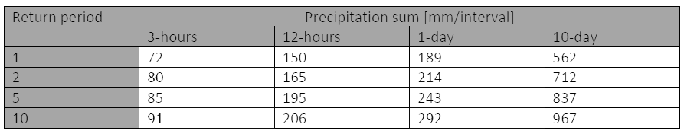

Figure 1 Precipitation sum for various return periods from Cox’s Bazar2

The precipitation sum for a return period of two years is 46 mm and 113 mm for respectively an event of one and six hours. An IDF-curve is used to interpolate and extrapolate to get a one and six-hour event. The values are compared with Dhaka, see Figure 2.

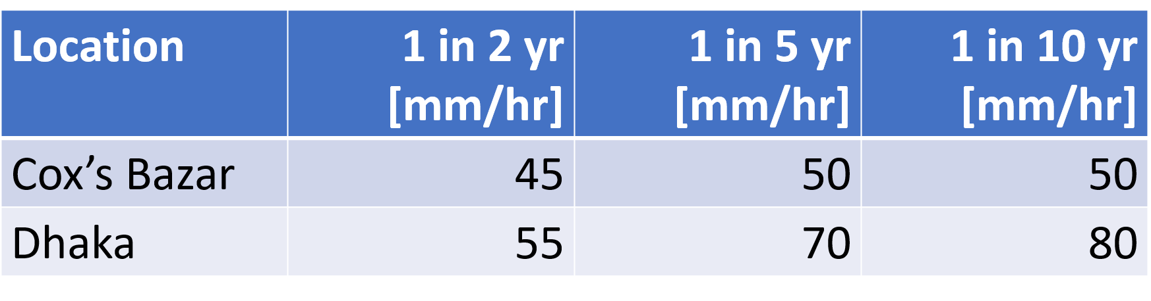

Figure 2 Rounded precipitation sum for a one-hour rainfall event in Cox’s Bazar and Dhaka1, 2

The rainfall statistics of Cox’s Bazar are much lower than Dhaka. This raises a question about the quality of the current rainfall data. If new data is available, it is advised to perform a rainfall analysis. Due to the high level of uncertainty with the rainfall and infiltration data, infiltration which is probably differing between approximately on average 4 and 16 mm per hour for the camps is neglected[3] in this analysis.

## Design rainfall events

Primary up to tertiary drainage is responding very fast in the camps, even with an hour. With a drainage system properly connected to the primary channels, water will be gone quickly due to the height difference. Therefore, a design rainfall event is selected with a rainfall intensity of 50 mm in one hour as default in the toolbox.

The rivers, like Madhurchara river, is responding fast, due to the hill shaped environment of the refugee camps. However, this system will take some time to fill up and there is some travel time of water from the upstream side of the camp, e.g. camp 4X, to the downstream side of the catchment, e.g. camp 7/8. The travel time of the water is at maximum 6 hours[4] from camp 20X to camp 8E. Therefore, a design rainfall event of 120 mm is created based on the round values of 1-, 3- and 6-hours rainfall event with a return period of 2 years. This event is shown in Figure 3.

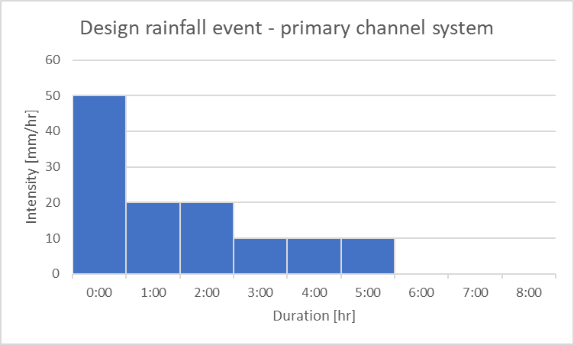

Figure 3 – Design rainfall event for primary channel system based on a return period of two years

1. Khan, Dr. M. Shah Alam (2015), Guidelines for Flood Risk Assessment and Stormwater Drainage Plan, Mymensingh Strategic Development Plan Project, 2011-2031, http://www.msdp.gov.bd/reports/report_drainage.pdf
2. Deltares (2019), Flood modelling in Kutupalong Refugee Camp, Bangladesh, Result Presentation for SMEP, 24 January 2019.
3. An infiltration rate is assumed of 10 mm/hour (sandy clay) and 20 mm/hour (sand) and a shelter density rate is varying between 20 and 60%.
4. For this estimation, the method of Kirpich is used. This method gives an estimation of an entire watershed to contribute to the downstream point of interest. For the Madhurchara catchment, there is a height difference between 11 and 40 metres over a distance of around 10 km starting at Camp 4X/20X and ending at Camp 8EF. This results in a time of concentration between 3 and 6 hours.  
   see also http://onlinemanuals.txdot.gov/txdotmanuals/hyd/time_of_concentration.htm#i1108228.